**My Project**

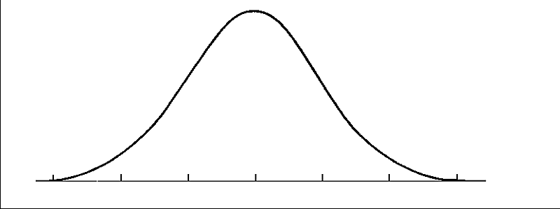

**My Name**

**My Affiliation**

Table of Contents

**Type chapter title (level 1)1**

Type chapter title (level 2)2

Type chapter title (level 3)3

**Type chapter title (level 1)4**

Type chapter title (level 2)5

Type chapter title (level 3)6

1. **Summary**

Short summary, main results, conclusion

1. **Introduction**

Set the context, background description, reason for work. Formulation of research questions, client-specific information

1. **Data**

Data description:

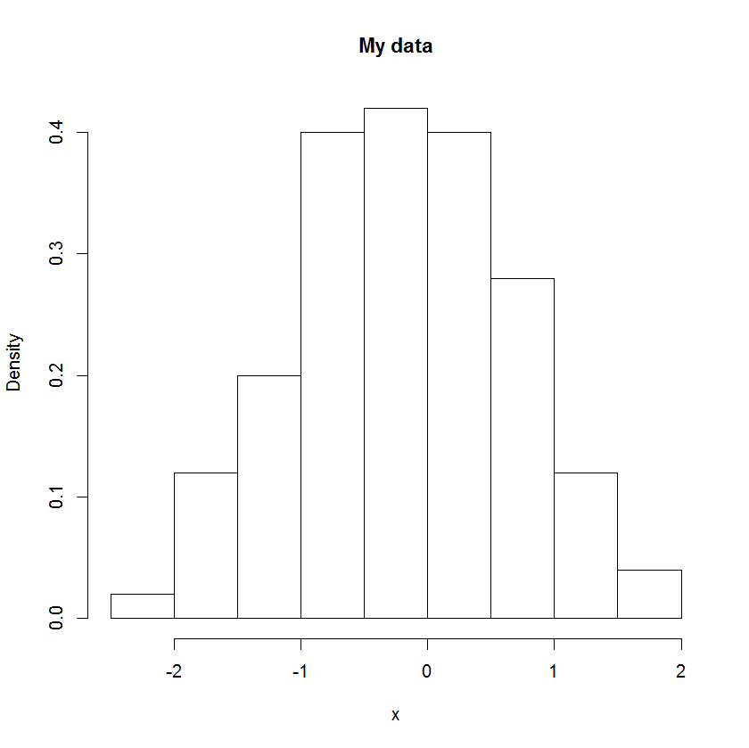

|  |  |  |  |
| --- | --- | --- | --- |
| Variable | Mean | sd | n |
| V1 | 8.99 | 1.11 | 742 |
| V2 | 9.42 | 0.47 | 1118 |
| V3 | 9.11 | 1.70 | 635 |

“V4 is scattered and inappropriate for the questions posed. V4 has therefore not been analyzed.”

Specification of outcomes, explanatory variables etc.

1. **Statistical Analyses**

Specification of statistical models and methods used. Model control.

1. **Results**

Results in TABLES:

|  |  |  |  |
| --- | --- | --- | --- |
| Variable | $$\hat{α}(sd)$$ | $$\hat{β}(sd)$$ | p |
| V1 | 1.11 | 1.23 | 0.14 |
| V2 | 45.83 | 4.56 | <0.0001*** |
| V3 | -2.42 | 7.89 | 0.02* |

Matter of fact, possibly graphs.

1. **Discussion**

Interpret results in context, communicate to the client. Address modeling issues.

1. **Conclusion**

Summarize analyses. Adress research questions. Make reservations, and address the interests of the client.

1. **Appendix**

Material not of immediate importance